***This is a bonus Web chapter

CHAPTER 35

Internationalization

Objectives
- To describe Java's internationalization features (§35.1).
- To construct a locale with language, country, and variant (§35.2).
- To display date and time based on locale (§35.3).
- To display numbers, currencies, and percentages based on locale (§35.4).
- To develop applications for international audiences using resource bundles (§35.5).
- To specify encoding schemes for text I/O (§35.6).
35.1 Introduction

Many Web sites maintain several versions of Web pages so that readers can choose one written in a language they understand. Because there are so many languages in the world, it would be highly problematic to create and maintain enough different versions to meet the needs of all clients everywhere. Java comes to the rescue. Java is the first language designed from the ground up to support internationalization. In consequence, it allows your programs to be customized for any number of countries or languages without requiring cumbersome changes in the code.

Here are the major Java features that support internationalization:

<margin note: Unicode>
- Java characters use Unicode, a 16-bit encoding scheme established by the Unicode Consortium to support the interchange, processing, and display of written texts in the world’s diverse languages. The use of Unicode encoding makes it easy to write Java programs that can manipulate strings in any international language. (To see all the Unicode characters, visit mindprod.com/jgloss/reuters.html.)

<margin note: Locale class>
- Java provides the Locale class to encapsulate information about a specific locale. A Locale object determines how locale-sensitive information, such as date, time, and number, is displayed, and how locale-sensitive operations, such as sorting strings, are performed. The classes for formatting date, time, and numbers, and for sorting strings are grouped in the java.text package.

<margin note: ResourceBundle>
- Java uses the ResourceBundle class to separate locale-specific information, such as status messages and GUI component labels, from the program. The information is stored outside the source code and can be accessed and loaded dynamically at runtime from a ResourceBundle, rather than hard-coded into the program.

In this chapter, you will learn how to format dates, numbers, currencies, and percentages for different regions, countries, and languages. You will also learn how to use resource bundles to define which images and strings are used by a component, depending on the user’s locale and preferences.

35.2 The Locale Class
A Locale object represents a geographical, political, or cultural region in which a specific language or custom is used. For example, Americans speak English, and the Chinese speak Chinese. The conventions for formatting dates, numbers, currencies, and percentages may differ from one country to another. The Chinese, for instance, use year/month/day to represent the date, while Americans use month/day/year. It is important to realize that locale is not defined only by country. For example, Canadians speak either Canadian English or Canadian French, depending on which region of Canada they reside in.

NOTE
<margin note: locale property in Component>
Every Swing user-interface class has a locale property inherited from the Component class.

To create a Locale object, use one of the three constructors with a specified language and optional country and variant, as shown in Figure 35.1.

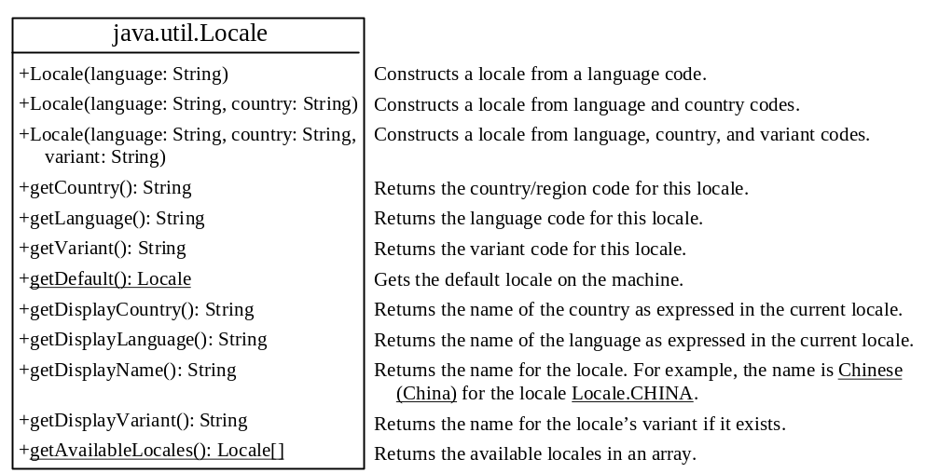

Figure 35.1
The Locale class encapsulates a locale.
<margin note: language>
The language should be a valid language code—that is, one of the lowercase two-letter codes defined by ISO-639. For example, zh stands for Chinese, da for Danish, en for English, de for German, and ko for Korean. Table 35.1 lists the language codes.

<margin note: country>
The country should be a valid ISO country code—that is, one of the uppercase, two-letter codes defined by ISO-3166. For example, CA stands for Canada, CN for China, DK for Denmark, DE for Germany, and US for the United States. Table 35.2 lists the country codes.
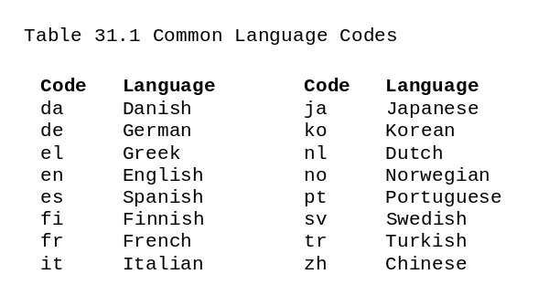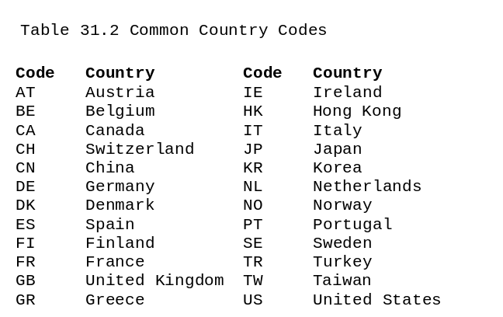
<margin note: variant>
The argument variant is rarely used and is needed only for exceptional or system-dependent situations to designate information specific to a browser or vendor. For example, the Norwegian language has two sets of spelling rules, a traditional one called bokmål and a new one called nynorsk. The locale for traditional spelling would be created as follows:

new Locale("no", "NO", "B");

For convenience, the Locale class contains many predefined locale constants. Locale.CANADA is for the country Canada and language English; Locale.CANADA_FRENCH is for the country Canada and language French. Several other common constants are:

The Locale class also provides the following constants based on language:
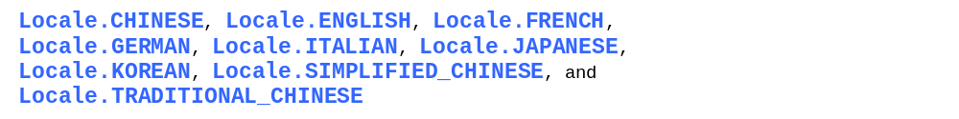

TIP:
You can invoke the static method getAvailableLocales() in the Locale class to obtain all the available locales supported in the system. For example,

Locale[] availableLocales = Calendar.getAvailableLocales();

returns all the locales in an array.

TIP:
Your machine has a default locale. You may override it by supplying the language and region parameters when you run the program, as follows:

java –Duser.language=zh –Duser.region=CN MainClass

<margin note: locale sensitive>
An operation that requires a Locale to perform its task is called locale sensitive. Displaying a number such as a date or time, for example, is a locale-sensitive operation; the number should be formatted according to the customs and conventions of the user's locale. The sections that follow introduce locale-sensitive operations.

35.3 Displaying Date and Time
<margin note: Date>
<margin note: Calendar>
Applications often need to obtain date and time. Java provides a system-independent encapsulation of date and time in the java.util.Date class; it also provides java.util.TimeZone for dealing with time zones, and java.util.Calendar for extracting detailed information from Date. Different locales have different conventions for displaying date and time. Should the year, month, or day be displayed first? Should slashes, periods, or colons be used to separate fields of the date? What are the names of the months in the language? The java.text.DateFormat class can be used to format date and time in a locale-sensitive way for display to the user. The Date class was introduced in §8.6.1, “The Date Class,” and the Calendar class and its subclass GregorianCalendar were introduced in §15.4, “Case Study: Calendar and GregorianCalendar.”

35.3.1 The TimeZone Class
<margin note: TimeZone>
TimeZone represents a time zone offset and also figures out daylight savings. To get a TimeZone object for a specified time zone ID, use TimeZone.getTimeZone(id). To set a time zone in a Calendar object, use the setTimeZone method with a time zone ID. For example, cal.setTimeZone(TimeZone.getTimeZone("CST")) sets the time zone to Central Standard Time. To find all the available time zones supported in Java, use the static method getAvailableIDs() in the TimeZone class. In general, the international time zone ID is a string in the form of continent/city like Europe/Berlin, Asia/Taipei, and America/Washington. You can also use the static method getDefault() in the TimeZone class to obtain the default time zone on the host machine.

35.3.2 The DateFormat Class
<margin note: DateFormat>
The DateFormat class can be used to format date and time in a number of styles. The DateFormat class supports several standard formatting styles. To format date and time, simply create an instance of DateFormat using one of the three static methods getDateInstance, getTimeInstance, and getDateTimeInstance and apply the format(Date) method on the instance, as shown in Figure 35.2.

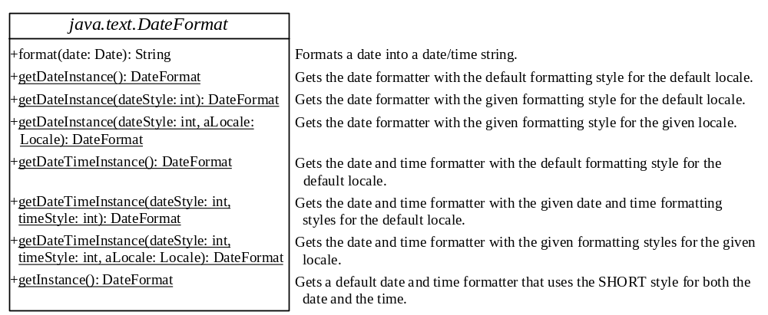

Figure 35.2
The DateFormat class formats date and time.

The dateStyle and timeStyle are one of the following constants: DateFormat.SHORT, DateFormat.MEDIUM, DateFormat.LONG, DateFormat.FULL. The exact result depends on the locale, but generally,

- SHORT is completely numeric, such as 7/24/98 (for date) and 4:49 PM (for time).
- MEDIUM is longer, such as 24-Jul-98 (for date) and 4:52:09 PM (for time).
- LONG is even longer, such as July 24, 1998 (for date) and 4:53:16 PM EST (for time).
- FULL is completely specified, such as Friday, July 24, 1998 (for date) and 4:54:13 o'clock PM EST (for time).

The statements given below display current time with a specified time zone (CST), formatting style (full date and full time), and locale (US).

GregorianCalendar calendar = new GregorianCalendar();

DateFormat formatter = DateFormat.getDateTimeInstance(

DateFormat.FULL, DateFormat.FULL, Locale.US);

TimeZone timeZone = TimeZone.getTimeZone("CST");
formatter.setTimeZone(timeZone);

System.out.println("The local time is " +
formatter.format(calendar.getTime()));

35.3.3 The SimpleDateFormat Class
<margin note: SimpleDateFormat>
The date and time formatting subclass, SimpleDateFormat, enables you to choose any user-defined pattern for date and time formatting. The constructor shown below can be used to create a SimpleDateFormat object, and the object can be used to convert a Date object into a string with the desired format.

public SimpleDateFormat(String pattern)

The parameter pattern is a string consisting of characters with special meanings. For example, y means year, M means month, d means day of the month, G is for era designator, h means hour, m means minute of the hour, s means second of the minute, and z means time zone. Therefore, the following code will display a string like "Current time is 1997.11.12 AD at 04:10:18 PST" because the pattern is "yyyy.MM.dd G 'at' hh:mm:ss z".

SimpleDateFormat formatter
= new SimpleDateFormat("yyyy.MM.dd G 'at' hh:mm:ss z");
date currentTime = new Date();

String dateString = formatter.format(currentTime);

System.out.println("Current time is " + dateString);

35.3.4 The DateFormatSymbols Class
<margin note: DateFormatSymbols>
The DateFormatSymbols class encapsulates localizable date-time formatting data, such as the names of the months and the names of the days of the week, as shown in Figure 35.3.
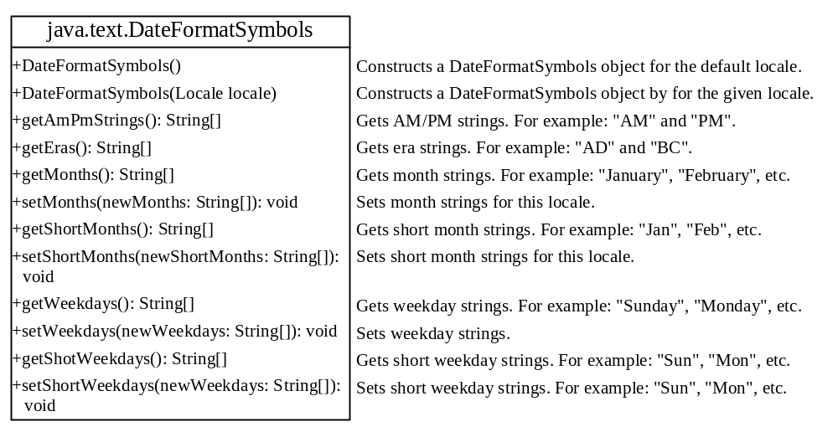

Figure 35.3
The DateFormatSymbols class encapsulates localizable date-time formatting data.

For example, the following statement displays the month names and weekday names for the default locale.

DateFormatSymbols symbols = new DateFormatSymbols();

String[] monthNames = symbols.getMonths();
for (int i = 0; i < monthNames.length; i++) {

System.out.println(monthNames[i]); // Display January, ...
}

String[] weekdayNames = symbols.getWeekdays();
for (int i = 0; i < weekdayNames.length; i++) {

System.out.println(weekdayNames[i]); // Display Sunday, Monday, ...
}

The following two examples demonstrate how to display date, time, and calendar based on locale. The first example creates a clock and displays date and time in locale-sensitive format. The second example displays several different calendars with the names of the days shown in the appropriate local language.

35.3.5 Example: Displaying an International Clock
Write a program that displays a clock to show the current time based on the specified locale and time zone. The locale and time zone are selected from the combo boxes that contain the available locales and time zones in the system, as shown in Figure 35.4.

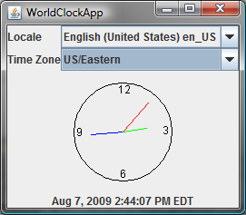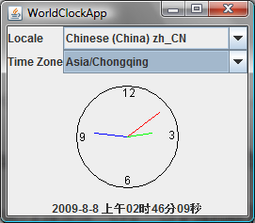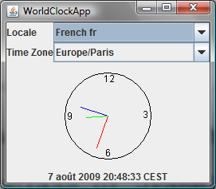

Figure 35.4
The program displays a clock that shows the current time with the specified locale and time zone.

Here are the major steps in the program:
1. Create a subclass of JPanel named WorldClock (Listing 35.1) to contain an instance of the StillClock class (developed in Listing 13.10, StillClock.java), and place it in the center. Create a JLabel to display the digit time, and place it in the south. Use the GregorianCalendar class to obtain the current time for a specific locale and time zone.
2. Create a subclass of JPanel named WorldClockControl (Listing 35.2) to contain an instance of WorldClock and two instances of JComboBox for selecting locales and time zones.
3. Create an applet named WorldClockApp (Listing 35.3) to contain an instance of WorldClockControl and enable the applet to run standalone.
The relationship among these classes is shown in Figure 35.5.
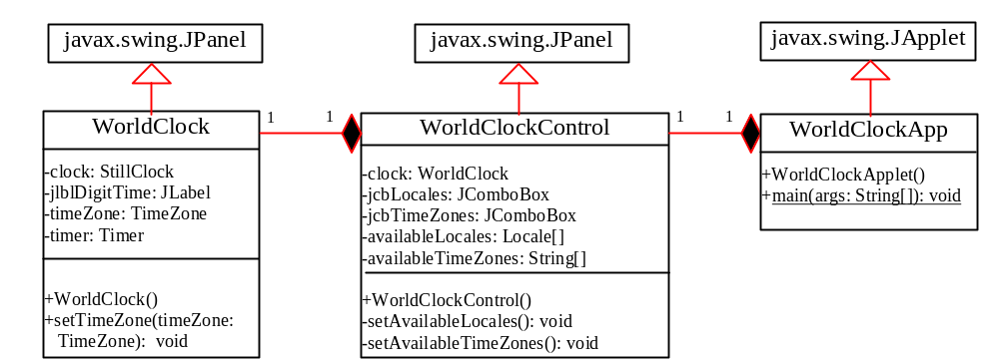

Figure 35.5
WorldClockApp contains WorldClockControl, and WorldClockControl contains WorldClock.

Listing 35.1 WorldClock.java
<margin note line 11: create timer>
<margin note line 12: create clock>
<margin note line 26: timer listener class>

1 import javax.swing.*;
2 import java.awt.*;
3 import java.awt.event.*;
4 import java.util.Calendar;
5 import java.util.TimeZone;
6 import java.util.GregorianCalendar;
7 import java.text.*;
8
9 public class WorldClock extends JPanel {
10 private TimeZone timeZone = TimeZone.getTimeZone("EST");
11 private Timer timer = new Timer(1000, new TimerListener());
12 private StillClock clock = new StillClock();
13 private JLabel jlblDigitTime = new JLabel("", JLabel.CENTER);
14
15 public WorldClock() {
16 setLayout(new BorderLayout());
17 add(clock, BorderLayout.CENTER);
18 add(jlblDigitTime, BorderLayout.SOUTH);
19 timer.start();
20 }
21
22 public void setTimeZone(TimeZone timeZone) {
23 this.timeZone = timeZone;
24 }
25
26 private class TimerListener implements ActionListener {
27 @Override
28 public void actionPerformed(ActionEvent e) {
- Calendar calendar =
- new GregorianCalendar(timeZone, getLocale());
31 clock.setHour(calendar.get(Calendar.HOUR));
32 clock.setMinute(calendar.get(Calendar.MINUTE));
33 clock.setSecond(calendar.get(Calendar.SECOND));
34
35 // Display digit time on the label
36 DateFormat formatter = DateFormat.getDateTimeInstance
37 (DateFormat.MEDIUM, DateFormat.LONG, getLocale());
38 formatter.setTimeZone(timeZone);
39 jlblDigitTime.setText(formatter.format(calendar.getTime()));
40 }
41 }
42 }

Listing 35.2 WorldClockControl.java
<margin note line 8: locales>
<margin note line 9: time zones>
<margin note line 12: combo boxes>
<margin note line 16: create clock>
<margin note line 31: create UI>
<margin note line 53: new locale>
<margin note line 59: new time zone>

1 import javax.swing.*;
2 import java.awt.*;
3 import java.awt.event.*;
4 import java.util.*;
5
6 public class WorldClockControl extends JPanel {
7 // Obtain all available locales and time zone ids
8 private Locale[] availableLocales = Locale.getAvailableLocales();
9 private String[] availableTimeZones = TimeZone.getAvailableIDs();
10
11 // Comboxes to display available locales and time zones
12 private JComboBox jcbLocales = new JComboBox();
13 private JComboBox jcbTimeZones = new JComboBox();
14
15 // Create a clock
16 private WorldClock clock = new WorldClock();
17
18 public WorldClockControl() {
19 // Initialize jcbLocales with all available locales
20 setAvailableLocales();
21
22 // Initialize jcbTimeZones with all available time zones
23 setAvailableTimeZones();
24
25 // Initialize locale and time zone
26 clock.setLocale(
27 availableLocales[jcbLocales.getSelectedIndex()]);
28 clock.setTimeZone(TimeZone.getTimeZone(
29 availableTimeZones[jcbTimeZones.getSelectedIndex()]));
30
31 JPanel panel1 = new JPanel();
32 panel1.setLayout(new GridLayout(2, 1));
33 panel1.add(new JLabel("Locale"));
34 panel1.add(new JLabel("Time Zone"));
35 JPanel panel2 = new JPanel();
36
37 panel2.setLayout(new GridLayout(2, 1));
38 panel2.add(jcbLocales, BorderLayout.CENTER);
39 panel2.add(jcbTimeZones, BorderLayout.CENTER);
40
41 JPanel panel3 = new JPanel();
42 panel3.setLayout(new BorderLayout());
43 panel3.add(panel1, BorderLayout.WEST);
44 panel3.add(panel2, BorderLayout.CENTER);
45
46 setLayout(new BorderLayout());
47 add(panel3, BorderLayout.NORTH);
48 add(clock, BorderLayout.CENTER);
49
50 jcbLocales.addActionListener(new ActionListener() {
51 @Override
52 public void actionPerformed(ActionEvent e) {
53 clock.setLocale(
54 availableLocales[jcbLocales.getSelectedIndex()]);
55 }
56 });
57 jcbTimeZones.addActionListener(new ActionListener() {
58 @Override
59 public void actionPerformed(ActionEvent e) {
60 clock.setTimeZone(TimeZone.getTimeZone(
61 availableTimeZones[jcbTimeZones.getSelectedIndex()]));
62 }
63 });
64 }
65
66 private void setAvailableLocales() {
67 for (int i = 0; i < availableLocales.length; i++) {
68 jcbLocales.addItem(availableLocales[i].getDisplayName() + " "
69 + availableLocales[i].toString());
70 }
71 }
72
73 private void setAvailableTimeZones() {
74 // Sort time zones
75 Arrays.sort(availableTimeZones);
76 for (int i = 0; i < availableTimeZones.length; i++) {
77 jcbTimeZones.addItem(availableTimeZones[i]);
78 }
79 }
80 }

Listing 35.3 WorldClockApp.java
<margin note line 8: main method omitted>

1 import javax.swing.*;
2
3 public class WorldClockApp extends JApplet {
4 /** Construct the applet */
5 public WorldClockApp() {
6 add(new WorldClockControl());
7 }
8 }

The WorldClock class uses GregorianCalendar to obtain a Calendar object for the specified locale and time zone (line 28). Since WorldClock extends JPanel, and every GUI component has the locale property, the locale for the calendar is obtained from the WorldClock using getLocale() (line 28).
An instance of StillClock is created (line 12) and placed in the panel (line 17). The clock time is updated every one second using the current Calendar object in lines 28–35.

An instance of DateFormat is created (lines 34–35) and is used to format the date in accordance with the locale (line 37).

The WorldClockControl class contains an instance of WorldClock and two combo boxes. The combo boxes store all the available locales and time zones (lines 64–77). The newly selected locale and time zone are set in the clock (lines 50–61) and used to display a new time based on the current locale and time zone.

35.3.6 Example: Displaying a Calendar

Write a program that displays a calendar based on the specified locale, as shown in Figure 35.6. The user can specify a locale from a combo box that consists of a list of all the available locales supported by the system. When the program starts, the calendar for the current month of the year is displayed. The user can use the Prior and Next buttons to browse the calendar.

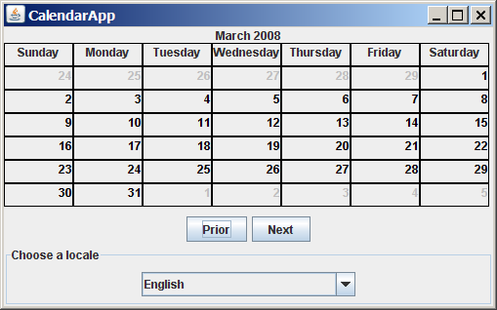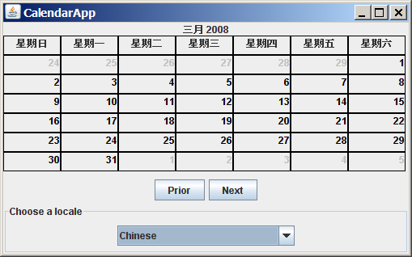

Figure 35.6
The calendar applet displays a calendar with a specified locale.

Here are the major steps in the program:
1. Create a subclass of JPanel named CalendarPanel (Listing 35.4) to display the calendar for the given year and month based on the specified locale and time zone.
2. Create an applet named CalendarApp (Listing 35.5). Create a panel to hold an instance of CalendarPanel and two buttons, Prior and Next. Place the panel in the center of the applet. Create a combo box and place it in the south of the applet. The relationships among these classes are shown in Figure 35.7.

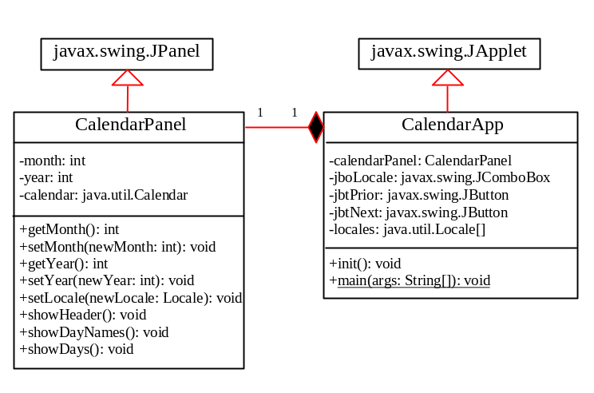

Figure 35.7

CalendarApp contains CalendarPanel.

Listing 35.4 CalendarPanel.java
<margin note line 9: label for header>
<margin note line 12: labels for days>
<margin note line 14: calendar>
<margin note line 15: month>
<margin note line 16: year>
<margin note line 19: panel for days>
<margin note line 23: create labels>
<margin note line 32: place header>
<margin note line 33: place day>
<margin note line 36: get current calendar>
<margin note line 39: update calendar>
<margin note line 42: show header>
<margin note line 43: show days>
<margin note line 47: show header>
<margin note line 51: new header>
<margin note line 57: get day names>
<margin note line 69: empty jpDays panel>
<margin note line 71: display day names>
<margin note line 82: days before this month>
<margin note line 92: days in this month>
<margin note line 101: days after this month>
<margin note line 108: repaint jpDays>
<margin note line 113: update calendar>
<margin note line 125: set new month>
<margin note line 138: set new year>
<margin note line 146: set new locale>

1 import java.awt.*;
2 import javax.swing.*;
3 import javax.swing.border.LineBorder;
4 import java.util.*;
5 import java.text.*;
6
7 public class CalendarPanel extends JPanel {
8 // The header label
9 private JLabel jlblHeader = new JLabel(" ", JLabel.CENTER);
10
11 // Maximun number of labels to display day names and days
12 private JLabel[] jlblDay = new JLabel[49];
13
14 private java.util.Calendar calendar;
15 private int month; // The specified month
16 private int year; // The specified year
17
18 // Panel jpDays to hold day names and days
19 private JPanel jpDays = new JPanel(new GridLayout(0, 7));
20
21 public CalendarPanel() {
22 // Create labels for displaying days
23 for (int i = 0; i < 49; i++) {
24 jlblDay[i] = new JLabel();
25 jlblDay[i].setBorder(new LineBorder(Color.black, 1));
26 jlblDay[i].setHorizontalAlignment(JLabel.RIGHT);
27 jlblDay[i].setVerticalAlignment(JLabel.TOP);
28 }
29
30 // Place header and calendar body in the panel
31 this.setLayout(new BorderLayout());
32 this.add(jlblHeader, BorderLayout.NORTH);
33 this.add(jpDays, BorderLayout.CENTER);
34
35 // Set current month and year
36 calendar = new GregorianCalendar();
37 month = calendar.get(Calendar.MONTH);
38 year = calendar.get(Calendar.YEAR);
39 updateCalendar();
40
41 // Show calendar
42 showHeader();
43 showDays();
44 }
45
46 /** Update the header based on locale */
47 private void showHeader() {
48 SimpleDateFormat sdf =
49 new SimpleDateFormat("MMMM yyyy", getLocale());
50 String header = sdf.format(calendar.getTime());
51 jlblHeader.setText(header);
52 }
53
54 /** Update the day names based on locale */
55 private void showDayNames() {
56 DateFormatSymbols dfs = new DateFormatSymbols(getLocale());
57 String dayNames[] = dfs.getWeekdays();
58
59 // jlblDay[0], jlblDay[1], ..., jlblDay[6] for day names
60 for (int i = 0; i < 7; i++) {
61 jlblDay[i].setText(dayNames[i + 1]);
62 jlblDay[i].setHorizontalAlignment(JLabel.CENTER);
63 jpDays.add(jlblDay[i]); // Add to jpDays
64 }
65 }
66
67 /** Display days */
68 public void showDays() {
69 jpDays.removeAll(); // Remove all labels from jpDays
70
71 showDayNames(); // Display day names
72
73 // Get the day of the first day in a month
74 int startingDayOfMonth = calendar.get(Calendar.DAY_OF_WEEK);
75
76 // Fill the calendar with the days before this month
77 Calendar cloneCalendar = (Calendar)calendar.clone();
78 cloneCalendar.add(Calendar.DATE, -1); // Becomes preceding month
79 int daysInPrecedingMonth = cloneCalendar.getActualMaximum(
80 Calendar.DAY_OF_MONTH);
81
82 for (int i = 0; i < startingDayOfMonth - 1; i++) {
83 jlblDay[i + 7].setForeground(Color.LIGHT_GRAY);
84 jlblDay[i + 7].setText(daysInPrecedingMonth -
85 startingDayOfMonth + 2 + i + "");
86 jpDays.add(jlblDay[i + 7]); // Add to jpDays
87 }
88
89 // Display days of this month
90 int daysInCurrentMonth = calendar.getActualMaximum(
91 Calendar.DAY_OF_MONTH);
92 for (int i = 1; i <= daysInCurrentMonth; i++) {
93 jlblDay[i - 2 + startingDayOfMonth + 7].
94 setForeground(Color.black);
95 jlblDay[i - 2 + startingDayOfMonth + 7].setText(i + "");
96 jpDays.add(jlblDay[i - 2 + startingDayOfMonth + 7]);
97 }
98
99 // Fill the calendar with the days after this month
100 int j = 1;
101 for (int i = daysInCurrentMonth - 1 + startingDayOfMonth + 7;
102 i % 7 != 0; i++) {
103 jlblDay[i].setForeground(Color.LIGHT_GRAY);
104 jlblDay[i].setText(j++ + "");
105 jpDays.add(jlblDay[i]); // Add to jpDays
106 }
107
108 jpDays.repaint(); // Repaint the labels in jpDays
109 }
110
111 /** Set the calendar to the first day of the
112 * specified month and year */
113 private void updateCalendar() {
114 calendar.set(Calendar.YEAR, year);
115 calendar.set(Calendar.MONTH, month);
116 calendar.set(Calendar.DATE, 1);
117 }
118
119 /** Return month */
120 public int getMonth() {
121 return month;
122 }
123
124 /** Set a new month */
125 public void setMonth(int newMonth) {
126 month = newMonth;
127 updateCalendar();
128 showHeader();
129 showDays();
130 }
131
132 /** Return year */
133 public int getYear() {
134 return year;
135 }
136
137 /** Set a new year */
138 public void setYear(int newYear) {
139 year = newYear;
140 updateCalendar();
141 showHeader();
142 showDays();
143 }
144
145 /** Set a new locale */
146 public void changeLocale(Locale newLocale) {
147 setLocale(newLocale);
148 showHeader();
149 showDays();
150 }
151 }

CalendarPanel is created to control and display the calendar. It displays the month and year in the header, and the day names and days in the calendar body. The header and day names are locale sensitive.

<margin note: showHeader>
The showHeader method (lines 47–52) displays the calendar title in a form like "MMMM yyyy". The SimpleDateFormat class used in the showHeader method is a subclass of DateFormat. SimpleDateFormat allows you to customize the date format to display the date in various nonstandard styles.

<margin note: showDayNames>
The showDayNames method (lines 55–65) displays the day names in the calendar. The DateFormatSymbols class used in the showDayNames method is a class for encapsulating localizable date-time formatting data, such as the names of the months, the names of the days of the week, and the time-zone data. The getWeekdays method is used to get an array of day names.

<margin note: showDays>
The showDays method (lines 68–109) displays the days for the specified month of the year. As you can see in Figure 35.6, the labels before the current month are filled with the last few days of the preceding month, and the labels after the current month are filled with the first few days of the next month.
To fill the calendar with the days before the current month, a clone of calendar, named cloneCalendar, is created to obtain the days for the preceding month (line 77). cloneCalendar is a copy of calendar with separate memory space. Thus you can change the properties of cloneCalendar without corrupting the calendar object. The clone() method is defined in the Object class, which was introduced in §15.7, “The Cloneable Interface.” You can clone any object as long as its defining class implements the Cloneable interface. The Calendar class implements Cloneable.

The cloneCalendar.getActualMaximum(Calendar.DAY_OF_MONTH) method (lines 90–91) returns the number of days in the month for the specified calendar.

Listing 35.5 CalendarApp.java
<margin note line 9: calendar panel>
<margin note line 12: combo box>
<margin note line 15: locales>
<margin note line 23: create UI>
<margin note line 50: set a new locale>
<margin note line 60: previous month>
<margin note line 69: next month>
<margin note line 75: main method omitted>

1 import java.awt.*;
2 import java.awt.event.*;
3 import javax.swing.*;
4 import javax.swing.border.*;
5 import java.util.*;
6
7 public class CalendarApp extends JApplet {
8 // Create a CalendarPanel for showing calendars
9 private CalendarPanel calendarPanel = new CalendarPanel();
10
11 // Combo box for selecting available locales
12 private JComboBox jcboLocale = new JComboBox();
13
14 // Declare locales to store available locales
15 private Locale locales[] = Calendar.getAvailableLocales();
16
17 // Buttons Prior and Next for displaying prior and next month
18 private JButton jbtPrior = new JButton("Prior");
19 private JButton jbtNext = new JButton("Next");
20
21 /** Initialize the applet */
22 public void init() {
23 // Panel jpLocale to hold the combo box for selecting locales
24 JPanel jpLocale = new JPanel(new FlowLayout());
25 jpLocale.setBorder(new TitledBorder("Choose a locale"));
26 jpLocale.add(jcboLocale);
27
28 // Initialize the combo box to add locale names
29 for (int i = 0; i < locales.length; i++)
30 jcboLocale.addItem(locales[i].getDisplayName());
31
32 // Panel jpButtons to hold buttons
33 JPanel jpButtons = new JPanel(new FlowLayout());
34 jpButtons.add(jbtPrior);
35 jpButtons.add(jbtNext);
36
37 // Panel jpCalendar to hold calendarPanel and buttons
38 JPanel jpCalendar = new JPanel(new BorderLayout());
39 jpCalendar.add(calendarPanel, BorderLayout.CENTER);
40 jpCalendar.add(jpButtons, BorderLayout.SOUTH);
41
42 // Place jpCalendar and jpLocale to the applet
43 add(jpCalendar, BorderLayout.CENTER);
44 add(jpLocale, BorderLayout.SOUTH);
45
46 // Register listeners
47 jcboLocale.addActionListener(new ActionListener() {
48 @Override
49 public void actionPerformed(ActionEvent e) {
50 if (e.getSource() == jcboLocale)
51 calendarPanel.changeLocale(
52 locales[jcboLocale.getSelectedIndex()]);
53 }
54 });
55
56 jbtPrior.addActionListener(new ActionListener() {
57 @Override
58 public void actionPerformed(ActionEvent e) {
59 int currentMonth = calendarPanel.getMonth();
60 if (currentMonth == 0) // The previous month is 11 for Dec
61 calendarPanel.setYear(calendarPanel.getYear() - 1);
62 calendarPanel.setMonth((currentMonth - 1) % 12);
63 }});
64
65 jbtNext.addActionListener(new ActionListener() {
66 @Override
67 public void actionPerformed(ActionEvent e) {
68 int currentMonth = calendarPanel.getMonth();
69 if (currentMonth == 11) // The next month is 0 for Jan
70 calendarPanel.setYear(calendarPanel.getYear() + 1);
71
72 calendarPanel.setMonth((currentMonth + 1) % 12);
73 }});
74
75 calendarPanel.changeLocale(
76 locales[jcboLocale.getSelectedIndex()]);
77 }
78 }

CalendarApp creates the user interface and handles the button actions and combo box item selections for locales. The Calendar.getAvailableLocales() method (line 15) is used to find all the available locales that have calendars. Its getDisplayName() method returns the name of each locale and adds the name to the combo box (line 30). When the user selects a locale name in the combo box, a new locale is passed to calendarPanel, and a new calendar is displayed based on the new locale (lines 72–73).

35.4 Formatting Numbers
Formatting numbers is highly locale dependent. For example, number 5000.555 is displayed as 5,000.555 in the United States, but as 5 000,555 in France and as 5.000,555 in Germany.

Numbers are formatted using the java.text.NumberFormat class, an abstract base class that provides the methods for formatting and parsing numbers, as shown in Figure 35.8.

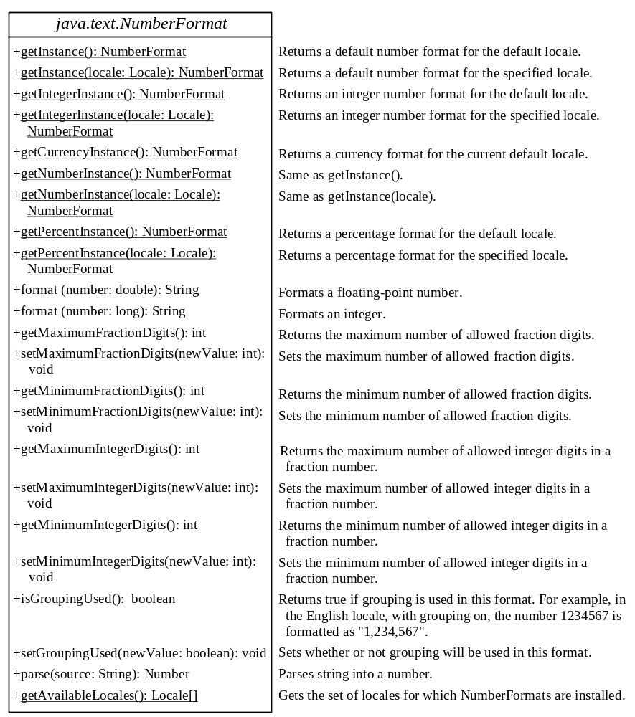

Figure 35.8
The NumberFormat class provides the methods for formatting and parsing numbers.

With NumberFormat, you can format and parse numbers for any locale. Your code will be completely independent of locale conventions for decimal points, thousands-separators, currency format, and percentage formats.

35.4.1 Plain Number Format
You can get an instance of NumberFormat for the current locale using NumberFormat.getInstance() or NumberFormat.getNumberInstance and for the specified locale using NumberFormat.getInstance(Locale) or NumberFormat.getNumberInstance(Locale). You can then invoke format(number) on the NumberFormat instance to return a formatted number as a string.

For example, to display number 5000.555 in France, use the following code:

NumberFormat numberFormat = NumberFormat.getInstance(Locale.FRANCE);

System.out.println(numberFormat.format(5000.555));

You can control the display of numbers with such methods as setMaximumFractionDigits and setMinimumFractionDigits. For example, 5000.555 will be displayed as 5000.6 if you use numberFormat.setMaximumFractionDigits(1).

35.4.2 Currency Format
To format a number as a currency value, use NumberFormat.getCurrencyInstance() to get the currency number format for the current locale or NumberFormat.getCurrencyInstance(Locale) to get the currency number for the specified locale.

For example, to display number 5000.555 as currency in the United States, use the following code:

NumberFormat currencyFormat =

NumberFormat.getCurrencyInstance(Locale.US);

System.out.println(currencyFormat.format(5000.555));

5000.555 is formatted into $5,000,56. If the locale is set to France, the number will be formatted into 5 000,56 €.

35.4.3 Percent Format
To format a number in a percent, use NumberFormat.getPercentInstance() or NumberFormat.getPercentInstance(Locale) to get the percent number format for the current locale or the specified locale.

For example, to display number 0.555367 as a percent in the United States, use the following code:

NumberFormat percentFormat =

NumberFormat.getPercentInstance(Locale.US);

System.out.println(percentFormat.format(0.555367));

0.555367 is formatted into 56%. By default, the format truncates the fraction part in a percent number. If you want to keep three digits after the decimal point, use percentFormat.setMinimumFractionDigits(3). So 0.555367 would be displayed as 55.537%.

35.4.4 Parsing Numbers

You can format a number into a string using the format(numericalValue) method. You can also use the parse(String) method to convert a formatted plain number, currency value, or percent number with the conventions of a certain locale into an instance of java.lang.Number. The parse method throws a java.text.ParseException if parsing fails. For example, U.S. $5,000.56 can be parsed into a number using the following statements:

NumberFormat currencyFormat =

NumberFormat.getCurrencyInstance(Locale.US);
try {

Number number = currencyFormat.parse("$5,000.56");

System.out.println(number.doubleValue());
}
catch (java.text.ParseException ex) {

System.out.println("Parse failed");
}

35.4.5 The DecimalFormat Class

If you want even more control over the format or parsing, cast the NumberFormat you get from the factory methods to a java.text.DecimalFormat, which is a subclass of NumberFormat. You can then use the applyPattern(String pattern) method of the DecimalFormat class to specify the patterns for displaying the number.

A pattern can specify the minimum number of digits before the decimal point and the maximum number of digits after the decimal point. The characters '0' and '#' are used to specify a required digit and an optional digit, respectively. The optional digit is not displayed if it is zero. For example, the pattern "00.0##" indicates minimum two digits before the decimal point and maximum three digits after the decimal point. If there are more actual digits before the decimal point, all of them are displayed. If there are more than three digits after the decimal point, the number of digits is rounded. Applying the pattern "00.0##", number 111.2226 is formatted to 111.223, number 1111.2226 to 1111.223, number 1.22 to 01.22, and number 1 to 01.0. Here is the code:

NumberFormat numberFormat = NumberFormat.getInstance(Locale.US);

DecimalFormat decimalFormat = (DecimalFormat)numberFormat;
decimalFormat.applyPattern("00.0##");

System.out.println(decimalFormat.format(111.2226));

System.out.println(decimalFormat.format(1111.2226));

System.out.println(decimalFormat.format(1.22));

System.out.println(decimalFormat.format(1));

The character '%' can be put at the end of a pattern to indicate that a number is formatted as a percentage. This causes the number to be multiplied by 100 and appends a percent sign %.

35.4.5 Example: Formatting Numbers

Create a loan calculator for computing loans. The calculator allows the user to choose locales, and displays numbers in accordance with locale-sensitive format. As shown in Figure 35.9, the user enters interest rate, number of years, and loan amount, then clicks the Compute button to display the interest rate in percentage format, the number of years in normal number format, and the loan amount, total payment, and monthly payment in currency format. Listing 35.6 gives the solution to the problem.

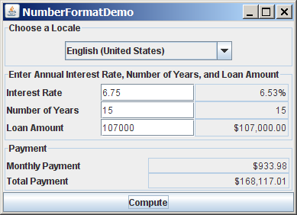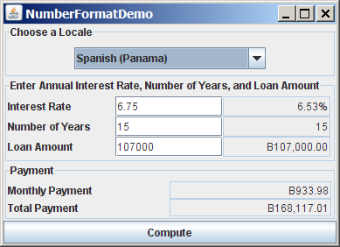

Figure 35.9
The locale determines the format of the numbers displayed in the loan calculator.

Listing 35.6 NumberFormatDemo.java
<margin note line 10: UI components>
<margin note line 42: create UI>
<margin note line 99: register listener>
<margin note line 101: new locale>
<margin note line 102: compute loan>
<margin note line 106: register listener>
<margin note line 114: compute loan>
<margin note line 145: main method omitted>
1 import java.awt.*;
2 import java.awt.event.*;
3 import javax.swing.*;
4 import javax.swing.border.*;
5 import java.util.*;
6 import java.text.NumberFormat;
7
8 public class NumberFormatDemo extends JApplet {
9 // Combo box for selecting available locales
10 private JComboBox jcboLocale = new JComboBox();
11
12 // Text fields for interest rate, year, and loan amount
13 private JTextField jtfInterestRate = new JTextField("6.75");
14 private JTextField jtfNumberOfYears = new JTextField("15");
15 private JTextField jtfLoanAmount = new JTextField("107000");
16 private JTextField jtfFormattedInterestRate = new JTextField(10);
17 private JTextField jtfFormattedNumberOfYears = new JTextField(10);
18 private JTextField jtfFormattedLoanAmount = new JTextField(10);
19
20 // Text fields for monthly payment and total payment
21 private JTextField jtfTotalPayment = new JTextField();
22 private JTextField jtfMonthlyPayment = new JTextField();
23
24 // Compute button
25 private JButton jbtCompute = new JButton("Compute");
26
27 // Current locale
28 private Locale locale = Locale.getDefault();
29
30 // Declare locales to store available locales
31 private Locale locales[] = Calendar.getAvailableLocales();
32
33 /** Initialize the combo box */
34 public void initializeComboBox() {
35 // Add locale names to the combo box
36 for (int i = 0; i < locales.length; i++)
37 jcboLocale.addItem(locales[i].getDisplayName());
38 }
39
40 /** Initialize the applet */
41 public void init() {
42 // Panel p1 to hold the combo box for selecting locales
43 JPanel p1 = new JPanel();
44 p1.setLayout(new FlowLayout());
45 p1.add(jcboLocale);
46 initializeComboBox();
47 p1.setBorder(new TitledBorder("Choose a Locale"));
48
49 // Panel p2 to hold the input
50 JPanel p2 = new JPanel();
51 p2.setLayout(new GridLayout(3, 3));
52 p2.add(new JLabel("Interest Rate"));
53 p2.add(jtfInterestRate);
54 p2.add(jtfFormattedInterestRate);
55 p2.add(new JLabel("Number of Years"));
56 p2.add(jtfNumberOfYears);
57 p2.add(jtfFormattedNumberOfYears);
58 p2.add(new JLabel("Loan Amount"));
59 p2.add(jtfLoanAmount);
60 p2.add(jtfFormattedLoanAmount);
61 p2.setBorder(new TitledBorder("Enter Annual Interest Rate, " +
62 "Number of Years, and Loan Amount"));
63
64 // Panel p3 to hold the result
65 JPanel p3 = new JPanel();
66 p3.setLayout(new GridLayout(2, 2));
67 p3.setBorder(new TitledBorder("Payment"));
68 p3.add(new JLabel("Monthly Payment"));
69 p3.add(jtfMonthlyPayment);
70 p3.add(new JLabel("Total Payment"));
71 p3.add(jtfTotalPayment);
72
73 // Set text field alignment
74 jtfFormattedInterestRate.setHorizontalAlignment(JTextField.RIGHT);
75 jtfFormattedNumberOfYears.setHorizontalAlignment(JTextField.RIGHT);
76 jtfFormattedLoanAmount.setHorizontalAlignment(JTextField.RIGHT);
77 jtfTotalPayment.setHorizontalAlignment(JTextField.RIGHT);
78 jtfMonthlyPayment.setHorizontalAlignment(JTextField.RIGHT);
79
80 // Set editable false
81 jtfFormattedInterestRate.setEditable(false);
82 jtfFormattedNumberOfYears.setEditable(false);
83 jtfFormattedLoanAmount.setEditable(false);
84 jtfTotalPayment.setEditable(false);
85 jtfMonthlyPayment.setEditable(false);
86
87 // Panel p4 to hold result payments and a button
88 JPanel p4 = new JPanel();
89 p4.setLayout(new BorderLayout());
90 p4.add(p3, BorderLayout.CENTER);
91 p4.add(jbtCompute, BorderLayout.SOUTH);
92
93 // Place panels to the applet
94 add(p1, BorderLayout.NORTH);
95 add(p2, BorderLayout.CENTER);
96 add(p4, BorderLayout.SOUTH);
97
98 // Register listeners
99 jcboLocale.addActionListener(new ActionListener() {
100 @Override
101 public void actionPerformed(ActionEvent e) {
102 locale = locales[jcboLocale.getSelectedIndex()];
103 computeLoan();
104 }
105 });
106
107 jbtCompute.addActionListener(new ActionListener() {
108 @Override
109 public void actionPerformed(ActionEvent e) {
110 computeLoan();
111 }
112 });
113 }
114
115 /** Compute payments and display results locale-sensitive format */
116 private void computeLoan() {
117 // Retrieve input from user
118 double loan = new Double(jtfLoanAmount.getText()).doubleValue();
119 double interestRate =
120 new Double(jtfInterestRate.getText()).doubleValue() / 1200;
121 int numberOfYears =
122 new Integer(jtfNumberOfYears.getText()).intValue();
123
124 // Calculate payments
125 double monthlyPayment = loan * interestRate/
126 (1 - (Math.pow(1 / (1 + interestRate), numberOfYears * 12)));
127 double totalPayment = monthlyPayment * numberOfYears * 12;
128
129 // Get formatters
130 NumberFormat percentFormatter =
131 NumberFormat.getPercentInstance(locale);
132 NumberFormat currencyForm =
133 NumberFormat.getCurrencyInstance(locale);
134 NumberFormat numberForm = NumberFormat.getNumberInstance(locale);
135 percentFormatter.setMinimumFractionDigits(2);
136
137 // Display formatted input
138 jtfFormattedInterestRate.setText(
139 percentFormatter.format(interestRate * 12));
140 jtfFormattedNumberOfYears.setText
141 (numberForm.format(numberOfYears));
142 jtfFormattedLoanAmount.setText(currencyForm.format(loan));
143
144 // Display results in currency format
145 jtfMonthlyPayment.setText(currencyForm.format(monthlyPayment));
146 jtfTotalPayment.setText(currencyForm.format(totalPayment));
147 }
148 }

The computeLoan method (lines 114–145) gets the input on interest rate, number of years, and loan amount from the user, computes monthly payment and total payment, and displays annual interest rate in percentage format, number of years in normal number format, and loan amount, monthly payment, and total payment in locale-sensitive format.

The statement percentFormatter.setMinimumFractionDigits(2) (line 133) sets the minimum number of fractional parts to 2. Without this statement, 0.075 would be displayed as 7% rather than 7.5%.

35.5 Resource Bundles
The NumberFormatDemo in the preceding example displays the numbers, currencies, and percentages in local customs, but displays all the message strings, titles, and button labels in English. In this section, you will learn how to use resource bundles to localize message strings, titles, button labels, and so on.

<margin note: resource bundle>
A resource bundle is a Java class file or text file that provides locale-specific information. This information can be accessed by Java programs dynamically. When a locale-specific resource is needed—a message string, for example—your program can load it from the resource bundle appropriate for the desired locale. In this way, you can write program code that is largely independent of the user's locale, isolating most, if not all, of the locale-specific information in resource bundles.

With resource bundles, you can write programs that separate the locale-sensitive part of your code from the locale-independent part. The programs can easily handle multiple locales, and can easily be modified later to support even more locales.

The resources are placed inside the classes that extend the ResourceBundle class or a subclass of ResourceBundle. Resource bundles contain key/value pairs. Each key uniquely identifies a locale-specific object in the bundle. You can use the key to retrieve the object. ListResourceBundle is a convenient subclass of ResourceBundle that is often used to simplify the creation of resource bundles. Here is an example of a resource bundle that contains four keys using ListResourceBundle:

// MyResource.java: resource file
public class MyResource extends java.util.ListResourceBundle {
static final Object[][] contents = {
{"nationalFlag", "us.gif"},
{"nationalAnthem", "us.au"},
{"nationalColor", Color.red},
{"annualGrowthRate", new Double(7.8)}
};

public Object[][] getContents() {
return contents;
}
}

Keys are case-sensitive strings. In this example, the keys are nationalFlag, nationalAnthem, nationalColor, and annualGrowthRate. The values can be any type of Object.

If all the resources are strings, they can be placed in a convenient text file with the extension .properties. A typical property file would look like this:

#Wed Jul 01 07:23:24 EST 1998
nationalFlag=us.gif
nationalAnthem=us.au

To retrieve values from a ResourceBundle in a program, you first need to create an instance of ResourceBundle using one of the following two static methods:

public static final ResourceBundle getBundle(String baseName)
throws MissingResourceException

public static final ResourceBundle getBundle
(String baseName, Locale locale) throws MissingResourceException

The first method returns a ResourceBundle for the default locale, and the second method returns a ResourceBundle for the specified locale. baseName is the base name for a set of classes, each of which describes the information for a given locale. These classes are named in Table 35.3.

Table 35.3:
Resource Bundle Naming Conventions
1. BaseName_language_country_variant.class
2. BaseName_language_country.class
3. BaseName_language.class
4. BaseName.class
5. BaseName_language_country_variant.properties
6. BaseName_language_country.properties
7. BaseName_language.properties
8. BaseName.properties

For example, MyResource_en_BR.class stores resources specific to the United Kingdom, MyResource_en_US.class stores resources specific to the United States, and MyResource_en.class stores resources specific to all the English-speaking countries.

The getBundle method attempts to load the class that matches the specified locale by language, country, and variant by searching the file names in the order shown in Table 35.3. The files searched in this order form a resource chain. If no file is found in the resource chain, the getBundle method raises a MissingResourceException, a subclass of RuntimeException.
Once a resource bundle object is created, you can use the getObject method to retrieve the value according to the key. For example,

ResourceBundle res = ResourceBundle.getBundle("MyResource");

String flagFile = (String)res.getObject("nationalFlag");

String anthemFile = (String)res.getObject("nationalAnthem");

Color color = (Color)res.getObject("nationalColor");
double growthRate = (Double)res.getObject("annualGrowthRate");

TIP
If the resource value is a string, the convenient getString method can be used to replace the getObject method. The getString method simply casts the value returned by getObject to a string.

What happens if a resource object you are looking for is not defined in the resource bundle? Java employs an intelligent look-up scheme that searches the object in the parent file along the resource chain. This search is repeated until the object is found or all the parent files in the resource chain have been searched. A MissingResourceException is raised if the search is unsuccessful.

Let us modify the NumberFormatDemo program in the preceding example so that it displays messages, title, and button labels in multiple languages, as shown in Figure 35.10.

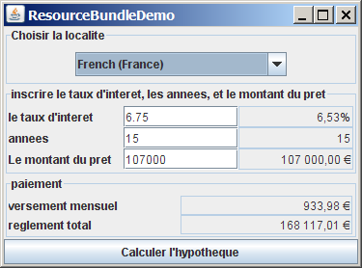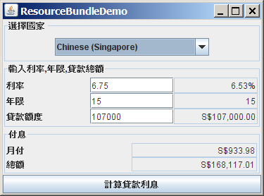

Figure 35.10

The program displays the strings in multiple languages.

You need to provide a resource bundle for each language. Suppose the program supports three languages: English (default), Chinese, and French. The resource bundle for the English language, named MyResource.properties, is given as follows:

#MyResource.properties for English language

Number_Of_Years=Years

Total_Payment=French Total\ Payment

Enter_Interest_Rate=Enter\ Interest\ Rate,\ Years,\ and\ Loan\ Amount

Payment=Payment

Compute=Compute

Annual_Interest_Rate=Interest\ Rate

Number_Formatting=Number\ Formatting\ Demo

Loan_Amount=Loan\ Amount

Choose_a_Locale=Choose\ a\ Locale

Monthly_Payment=Monthly\ Payment

The resource bundle for the Chinese language, named MyResource_zh.properties, is given as follows:

#MyResource_zh.properties for Chinese language
Choose_a_Locale = \u9078\u64c7\u570b\u5bb6

Enter_Interest_Rate =

\u8f38\u5165\u5229\u7387,\u5e74\u9650,\u8cb8\u6b3e\u7e3d\u984d

Annual_Interest_Rate = \u5229\u7387
Number_Of_Years = \u5e74\u9650
Loan_Amount = \u8cb8\u6b3e\u984d\u5ea6
Payment = \u4ed8\u606f
Monthly_Payment = \u6708\u4ed8
Total_Payment = \u7e3d\u984d
Compute = \u8a08\u7b97\u8cb8\u6b3e\u5229\u606f

The resource bundle for the French language, named MyResource_fr.properties, is given as follows:

#MyResource_fr.properties for French language

Number_Of_Years=annees

Annual_Interest_Rate=le taux d'interet

Loan_Amount=Le montant du pret

Enter_Interest_Rate=inscrire le taux d'interet, les annees, et le montant du pret

Payment=paiement

Compute=Calculer l'hypotheque

Number_Formatting=demonstration du formatting des chiffres

Choose_a_Locale=Choisir la localite

Monthly_Payment=versement mensuel

Total_Payment=reglement total

The resource-bundle file should be placed in the class directory (e.g., c:\book for the examples in this book). The program is given in Listing 35.7.

Listing 35.7 ResourceBundleDemo.java
<margin note line 11: get resource>
<margin note line 61: create UI>
<margin note line 120: register listener>
<margin note line 123: update resource>
<margin note line 128: register listener>
<margin note line 169: new resource>
<margin note line 192: res in applet>

1 import java.awt.*;
2 import java.awt.event.*;
3 import javax.swing.*;
4 import javax.swing.border.*;
5 import java.util.*;
6 import java.text.NumberFormat;
7
8 public class ResourceBundleDemo extends JApplet {
9 // Combo box for selecting available locales
10 private JComboBox jcboLocale = new JComboBox();
11 private ResourceBundle res = ResourceBundle.getBundle("MyResource");
12
13 // Create labels
14 private JLabel jlblInterestRate =
15 new JLabel(res.getString("Annual_Interest_Rate"));
16 private JLabel jlblNumberOfYears =
17 new JLabel(res.getString("Number_Of_Years"));
18 private JLabel jlblLoanAmount =
19 new JLabel(res.getString("Loan_Amount"));
20 private JLabel jlblMonthlyPayment =
21 new JLabel(res.getString("Monthly_Payment"));
22 private JLabel jlblTotalPayment =
23 new JLabel(res.getString("Total_Payment"));
24
25 // Create titled borders
26 private TitledBorder comboBoxTitle =
27 new TitledBorder(res.getString("Choose_a_Locale"));
28 private TitledBorder inputTitle = new TitledBorder
29 (res.getString("Enter_Interest_Rate"));
30 private TitledBorder paymentTitle =
31 new TitledBorder(res.getString("Payment"));
32
33 // Text fields for interest rate, year, loan amount,
34 private JTextField jtfInterestRate = new JTextField("6.75");
35 private JTextField jtfNumberOfYears = new JTextField("15");
36 private JTextField jtfLoanAmount = new JTextField("107000");
37 private JTextField jtfFormattedInterestRate = new JTextField(10);
38 private JTextField jtfFormattedNumberOfYears = new JTextField(10);
39 private JTextField jtfFormattedLoanAmount = new JTextField(10);
40
41 // Text fields for monthly payment and total payment
42 private JTextField jtfTotalPayment = new JTextField();
43 private JTextField jtfMonthlyPayment = new JTextField();
44
45 // Compute button
46 private JButton jbtCompute = new JButton(res.getString("Compute"));
47
48 // Current locale
49 private Locale locale = Locale.getDefault();
50
51 // Declare locales to store available locales
52 private Locale locales[] = Calendar.getAvailableLocales();
53
54 /** Initialize the combo box */
55 public void initializeComboBox() {
56 // Add locale names to the combo box
57 for (int i = 0; i < locales.length; i++)
58 jcboLocale.addItem(locales[i].getDisplayName());
59 }
60
61 /** Initialize the applet */
62 public void init() {
63 // Panel p1 to hold the combo box for selecting locales
64 JPanel p1 = new JPanel();
65 p1.setLayout(new FlowLayout());
66 p1.add(jcboLocale);
67 initializeComboBox();
68 p1.setBorder(comboBoxTitle);
69
70 // Panel p2 to hold the input for annual interest rate,
71 // number of years and loan amount
72 JPanel p2 = new JPanel();
73 p2.setLayout(new GridLayout(3, 3));
74 p2.add(jlblInterestRate);
75 p2.add(jtfInterestRate);
76 p2.add(jtfFormattedInterestRate);
77 p2.add(jlblNumberOfYears);
78 p2.add(jtfNumberOfYears);
79 p2.add(jtfFormattedNumberOfYears);
80 p2.add(jlblLoanAmount);
81 p2.add(jtfLoanAmount);
82 p2.add(jtfFormattedLoanAmount);
83 p2.setBorder(inputTitle);
84
85 // Panel p3 to hold the payment
86 JPanel p3 = new JPanel();
87 p3.setLayout(new GridLayout(2, 2));
88 p3.setBorder(paymentTitle);
89 p3.add(jlblMonthlyPayment);
90 p3.add(jtfMonthlyPayment);
91 p3.add(jlblTotalPayment);
92 p3.add(jtfTotalPayment);
93
94 // Set text field alignment
95 jtfFormattedInterestRate.setHorizontalAlignment
96 (JTextField.RIGHT);
97 jtfFormattedNumberOfYears.setHorizontalAlignment
98 (JTextField.RIGHT);
99 jtfFormattedLoanAmount.setHorizontalAlignment(JTextField.RIGHT);
100 jtfTotalPayment.setHorizontalAlignment(JTextField.RIGHT);
101 jtfMonthlyPayment.setHorizontalAlignment(JTextField.RIGHT);
102
103 // Set editable false
104 jtfFormattedInterestRate.setEditable(false);
105 jtfFormattedNumberOfYears.setEditable(false);
106 jtfFormattedLoanAmount.setEditable(false);
107 jtfTotalPayment.setEditable(false);
108 jtfMonthlyPayment.setEditable(false);
109
110 // Panel p4 to hold result payments and a button
111 JPanel p4 = new JPanel();
112 p4.setLayout(new BorderLayout());
113 p4.add(p3, BorderLayout.CENTER);
114 p4.add(jbtCompute, BorderLayout.SOUTH);
115
116 // Place panels to the applet
117 add(p1, BorderLayout.NORTH);
118 add(p2, BorderLayout.CENTER);
119 add(p4, BorderLayout.SOUTH);
120
121 // Register listeners
122 jcboLocale.addActionListener(new ActionListener() {
123 @Override
124 public void actionPerformed(ActionEvent e) {
125 locale = locales[jcboLocale.getSelectedIndex()];
126 updateStrings();
127 computeLoan();
128 }
129 });
130
131 jbtCompute.addActionListener(new ActionListener() {
132 @Override
133 public void actionPerformed(ActionEvent e) {
134 computeLoan();
135 }
136 });
137 }
138
139 /** Compute payments and display results locale-sensitive format */
140 private void computeLoan() {
141 // Retrieve input from user
142 double loan = new Double(jtfLoanAmount.getText()).doubleValue();
143 double interestRate =
144 new Double(jtfInterestRate.getText()).doubleValue() / 1200;
145 int numberOfYears =
146 new Integer(jtfNumberOfYears.getText()).intValue();
147
148 // Calculate payments
149 double monthlyPayment = loan * interestRate/
150 (1 - (Math.pow(1 / (1 + interestRate), numberOfYears * 12)));
151 double totalPayment = monthlyPayment * numberOfYears * 12;
152
153 // Get formatters
154 NumberFormat percentFormatter =
155 NumberFormat.getPercentInstance(locale);
156 NumberFormat currencyForm =
157 NumberFormat.getCurrencyInstance(locale);
158 NumberFormat numberForm = NumberFormat.getNumberInstance(locale);
159 percentFormatter.setMinimumFractionDigits(2);
160
161 // Display formatted input
162 jtfFormattedInterestRate.setText(
163 percentFormatter.format(interestRate * 12));
164 jtfFormattedNumberOfYears.setText
165 (numberForm.format(numberOfYears));
166 jtfFormattedLoanAmount.setText(currencyForm.format(loan));
167
168 // Display results in currency format
169 jtfMonthlyPayment.setText(currencyForm.format(monthlyPayment));
170 jtfTotalPayment.setText(currencyForm.format(totalPayment));
171 }
172
173 /** Update resource strings */
174 private void updateStrings() {
175 res = ResourceBundle.getBundle("MyResource", locale);
176 jlblInterestRate.setText(res.getString("Annual_Interest_Rate"));
177 jlblNumberOfYears.setText(res.getString("Number_Of_Years"));
178 jlblLoanAmount.setText(res.getString("Loan_Amount"));
179 jlblTotalPayment.setText(res.getString("Total_Payment"));
180 jlblMonthlyPayment.setText(res.getString("Monthly_Payment"));
181 jbtCompute.setText(res.getString("Compute"));
182 comboBoxTitle.setTitle(res.getString("Choose_a_Locale"));
183 inputTitle.setTitle(res.getString("Enter_Interest_Rate"));
184 paymentTitle.setTitle(res.getString("Payment"));
185
186 // Make sure the new labels are displayed
187 repaint();
188 }
189
190 /** Main method */
191 public static void main(String[] args) {
192 // Create an instance of the applet
193 ResourceBundleDemo applet = new ResourceBundleDemo();
194
195 // Create a frame with a resource string
196 JFrame frame = new JFrame(
197 applet.res.getString("Number_Formatting"));
198
199 // Add the applet instance to the frame
200 frame.add(applet, BorderLayout.CENTER);
201
202 // Invoke init() and start()
203 applet.init();
204 applet.start();
205
206 // Display the frame
207 frame.setSize(400, 300);
208 frame.setLocationRelativeTo(null);
209 frame.setDefaultCloseOperation(JFrame.EXIT_ON_CLOSE);
210 frame.setVisible(true);
211 }
212 }

Property resource bundles are implemented as text files with a .properties extension, and are placed in the same location as the class files for the application or applet. ListResourceBundles are provided as Java class files. Because they are implemented using Java source code, new and modified ListResourceBundles need to be recompiled for deployment. With PropertyResourceBundles, there is no need for recompilation when translations are modified or added to the application. Nevertheless, ListResourceBundles provide considerably better performance than PropertyResourceBundles.
If the resource bundle is not found or a resource object is not found in the resource bundle, a MissingResourceException is raised. Since MissingResourceException is a subclass of RuntimeException, you do not need to catch the exception explicitly in the code.

This example is the same as Listing 35.6, NumberFormatDemo.java, except that the program contains the code for handling resource strings. The updateString method (lines 172–186) is responsible for displaying the locale-sensitive strings. This method is invoked when a new locale is selected in the combo box. Since the variable res of the ResourceBundle class is an instance variable in ResourceBundleDemo, it cannot be directly used in the main method, because the main method is static. To fix the problem, create applet as an instance of ResourceBundleDemo, and you will then be able to reference res using applet.res.

35.6 Character Encoding

Java programs use Unicode. When you read a character using text I/O, the Unicode code of the character is returned. The encoding of the character in the file may be different from the Unicode encoding. Java automatically converts it to the Unicode. When you write a character using text I/O, Java automatically converts the Unicode of the character to the encoding specified for the file. This is pictured in Figure 35.11.

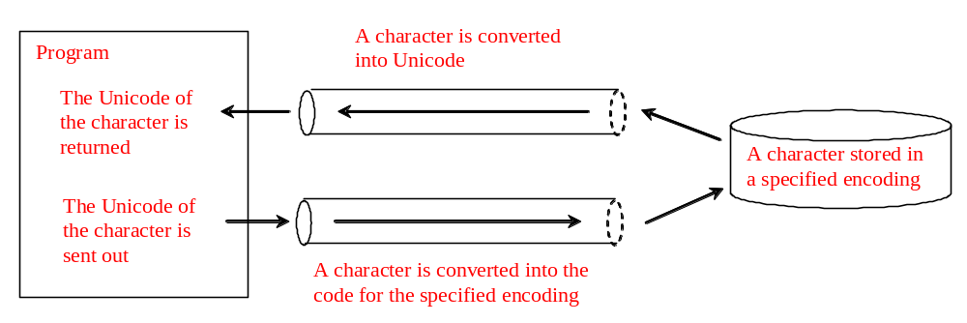

Figure 35.11
The encoding of the file may be different from the encoding used in the program.
You can specify an encoding scheme using a constructor of Scanner/PrintWriter for text I/O, as follows:

public Scanner(File file, String encodingName)
public PrintWriter(File file, String encodingName)

For a list of encoding schemes supported in Java, see http://download.oracle.com/javase/1.5.0/docs/guide/intl/encoding.doc.html and mindprod.com/jgloss/encoding.html. For example, you may use the encoding name GB18030 for simplified Chinese characters, Big5 for traditional Chinese characters, Cp939 for Japanese characters, Cp933 for Korean characters, and Cp838 for Thai characters.

The following code in Listing 35.8 creates a file using the GB18030 encoding (line 8). You have to read the text using the same encoding (line 12). The output is shown in Figure 35.12a.

Listing 35.8 EncodingDemo.java
<margin note line 8: specify encoding>
<margin note line 12: specify encoding>

1 import java.util.*;
2 import java.io.*;
3 import javax.swing.*;
4
5 public class EncodingDemo {
6 public static void main(String[] args)
7 throws IOException, FileNotFoundException {
8 PrintWriter output = new PrintWriter("temp.txt", "GB18030");
9 output.print("\u6B22\u8FCE Welcome \u03b1\u03b2\u03b3");
10 output.close();
11
12 Scanner input = new Scanner(new File("temp.txt"), "GB18030");
13 JOptionPane.showMessageDialog(null, input.nextLine());
14 }
15 }

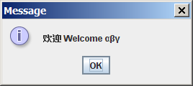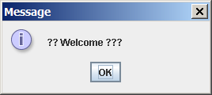
(a) Using GB18030 encoding (b) Using default encoding

Figure 35.12
You can specify an encoding scheme for a text file.

If you don’t specify an encoding in lines 8 and 12, the system’s default encoding scheme is used. The US default encoding is ASCII. ASCII code uses 8 bits. Java uses the 16-bit Unicode. If a Unicode is not an ASCII code, the character '?' is written to the file. Thus, when you write \u6B22 to an ASCII file, the ? character is written to the file. When you read it back, you will see the ? character, as shown in Figure 35.12b.

To find out the default encoding on your system, use

<margin note line 8: get default encoding>

System.out.println(System.getProperty("file.encoding"));

The default encoding name is Cp1252 on Windows, which is a variation of ASCII.

Key Terms

- locale 7
- resource bundle
- file encoding scheme

Chapter Summary
- Java is the first language designed from the ground up to support internationalization. In consequence, it allows your programs to be customized for any number of countries or languages without requiring cumbersome changes in the code.

- Java characters use Unicode in the program. The use of Unicode encoding makes it easy to write Java programs that can manipulate strings in any international language.

- Java provides the Locale class to encapsulate information about a specific locale. A Locale object determines how locale-sensitive information, such as date, time, and number, is displayed, and how locale-sensitive operations, such as sorting strings, are performed. The classes for formatting date, time, and numbers, and for sorting strings are grouped in the java.text package.

- Different locales have different conventions for displaying date and time. The java.text.DateFormat class and its subclasses can be used to format date and time in a locale-sensitive way for display to the user.

- To format a number for the default or a specified locale, use one of the factory class methods in the NumberFormat class to get a formatter. Use getInstance or getNumberInstance to get the normal number format. Use getCurrencyInstance to get the currency number format. Use getPercentInstance to get a format for displaying percentages.
- Java uses the ResourceBundle class to separate locale-specific information, such as status messages and GUI component labels, from the program. The information is stored outside the source code and can be accessed and loaded dynamically at runtime from a ResourceBundle, rather than hard-coded into the program.
- You can specify an encoding for a text file when constructing a PrintWriter or a Scanner.

Test Questions
Do the test questions for this chapter online at www.cs.armstrong.edu/liang/intro9e/test.html.

Review Questions

Sections 35.1-35.2

35.1
How does Java support international characters in languages like Chinese and Arabic?
35.2
How do you construct a Locale object? How do you get all the available locales from a Calendar object?

35.3
How do you set a locale for the French-speaking region of Canada in a Swing JButton? How do you set a locale for the Netherlands in a Swing JLabel?

Section 35.3
35.4
How do you set the time zone "PST" for a Calendar object?

35.5
How do you display current date and time in German?
35.6
How do you use the SimpleDateFormat class to display date and time using the pattern "yyyy.MM.dd hh:mm:ss"?

35.7
In line 73 of WorldClockControl.java, Arrays.sort(availableTimeZones) is used to sort the available time zones. What happens if you attempt to sort the available locales using Arrays.sort(availableLocales)?

Section 35.4
35.8
Write the code to format number 12345.678 in the United Kingdom locale. Keep two digits after the decimal point.

35.9
Write the code to format number 12345.678 in U.S. currency.
35.10
Write the code to format number 0.345678 as percentage with at least three digits after the decimal point.

35.11
Write the code to parse 3,456.78 into a number.
35.12
Write the code that uses the DecimalFormat class to format number 12345.678 using the pattern "0.0000#".

Section 35.5

35.13
How does the getBundle method locate a resource bundle?
35.14
How does the getObject method locate a resource?

Section 35.6

35.15
How do you specify an encoding scheme for a text file?
35.16
What would happen if you wrote a Unicode character to an ASCII text file?

35.17
How do you find the default encoding name on your system?

Programming Exercises

Sections 35.1-35.2
35.1*
(Unicode viewer) Develop an applet that displays Unicode characters, as shown in Figure 35.13. The user specifies a Unicode in the text field and presses the Enter key to display a sequence of Unicode characters starting with the specified Unicode. The Unicode characters are displayed in a scrollable text area of 20 lines. Each line contains 16 characters preceded by the Unicode that is the code for the first character on the line.

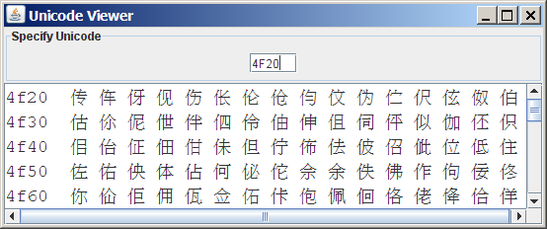

Figure 35.13

The applet displays the Unicode characters.

35.2**
(Display date and time) Write a program that displays the current date and time as shown in Figure 35.14. The program enables the user to select a locale, time zone, date style, and time style from the combo boxes.

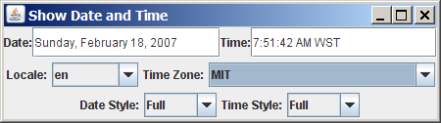

Figure 35.14

The program displays the current date and time.

Section 35.3
35.3
(Place the calendar and clock in a panel) Write an applet that displays the current date in a calendar and current time in a clock, as shown in Figure 35.15. Enable the applet to run standalone.

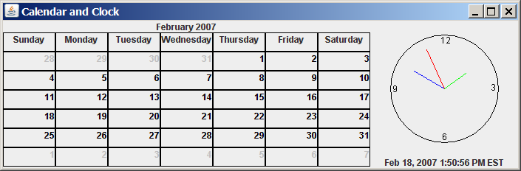

Figure 35.15

The calendar and clock display the current date and time.

35.4
(Find the available locales and time zone IDs) Write two programs to display the available locales and time zone IDs using buttons, as shown in Figure 35.16.

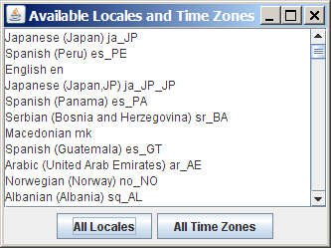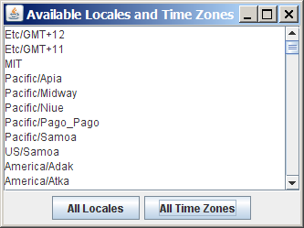

Figure 35.16
The program displays available locales and time zones using buttons.

Section 35.4
35.5*
(Compute loan amortization schedule) Rewrite Exercise 4.22 using an applet, as shown in Figure 35.17. The applet allows the user to set the loan amount, loan period, and interest rate, and displays the corresponding interest, principal, and balance in the currency format.

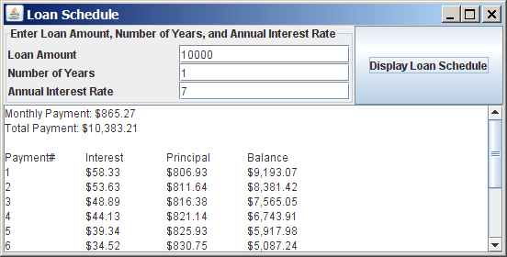

Figure 35.17

The program displays the loan payment schedule.

35.6
(Convert dollars to other currencies) Write a program that converts U.S. dollars to Canadian dollars, German marks, and British pounds, as shown in Figure 35.18. The user enters the U.S. dollar amount and the conversion rate, and clicks the Convert button to display the converted amount.

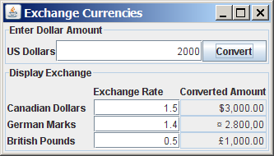

Figure 35.18
The program converts U.S. dollars to Canadian dollars, German marks, and British pounds.

35.7
(Compute loan payments) Rewrite Listing 2.8, ComputeLoan.java, to display the monthly payment and total payment in currency.

35.8
(Use the DecimalFormat class) Rewrite Exercise 5.8 to display at most two digits after the decimal point for the temperature using the DecimalFormat class.

Section 35.5
35.9*
(Use resource bundle) Modify the example for displaying a calendar in §35.3.6, “Example: Displaying a Calendar,” to localize the labels "Choose a locale" and "Calendar Demo" in French, German, Chinese, or a language of your choice.

35.10**
(Flag and anthem) Rewrite Listing 18.13, ImageAudioAnimation.java, to use the resource bundle to retrieve image and audio files.
(Hint: When a new country is selected, set an appropriate locale for it. Have your program look for the flag and audio file from the resource file for the locale.)

Section 35.6
35.11**
(Specify file encodings) Write a program named Exercise35_11Writer that writes 1307 × 16 Chinese Unicode characters starting from \u0E00 to a file named Exercise35_11.gb using the GBK encoding scheme. Output 16 characters per line and separate the characters with spaces. Write a program named Exercise35_11Reader that reads all the characters from a file using a specified encoding. Figure 35.19 displays the file using the GBK encoding scheme.

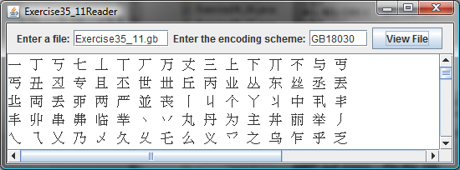

Figure 35.19
The program displays the file using the specified encoding scheme.

